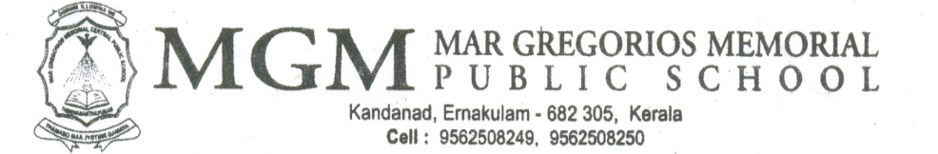

MGM/CR/2025-2026/07 20-06-2025

Dear Parents,
Greetings from MGM!

In connection with International Day Against Drug Abuse on 26th June, MGMPS Ernakulam is organizing various activities for students.
- Flash Mob
- Street Play
- Group Song
- “Say no to drug abuse” campaign

Regards,
Mrs. Lincy Antony
Programme Co-ordinator

