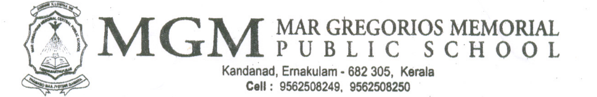

MGM/CR/2025-2026/21 24-09-2025

Dear Parents,
Greetings from MGM!

In connection with Gandhi Jayanti on 2nd October2025 , MGM Public School, Ernakulam, is organizing various activities on 29th September (Monday)for our students.
Activities
- Common assembly
- Class wise programmes
* Class 1 - Colouring
* Class 2 & 3 - Poster making
Topic: “Swachh Bharat”
* Class 4 & 5 - Slogan presentation
Topic: “Non-violence”
* Class 6 to 9 - “Small Hands, Big Change “– Campus cleanliness drive

- In connection with Ayurveda week an awareness session is organising on “The Timeless Wisdom of Ayurveda” for students of grades
6 to 9, led by Dr. Deepthy Susan Tharacheril , Assistant Professor, Govt. Ayurveda Medical College , Tripunithura on that day.

Regards,

Programme Coordinator
( Mrs. Reshmi A.K )

