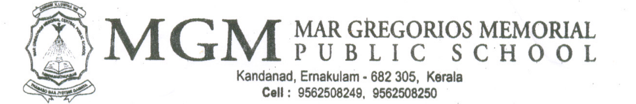

MGM/CR/2025-2026/15 12-08-2025

Dear Parents,
Greetings from MGM!

In connection with Independence Day, MGMPS Ernakulam is organizing the following activities.
14th August  - Speech (Hindi, Malayalam)  - Tribute  - Dance  - Fancy Dress  - Patriotic Song Competition  KG Programmes  - Speech  - Introducing National Leaders  - Dance  - Action Song  - Quiz | 15th August  - Flag Hoisting  - Band Display  - Speech (English)  - Patriotic Song

Regards,
Programme Coordinators
Mrs. Bindu Biji, Mrs. Sreerekha Venugopal

